Metronome

Tempo is measured in beats per minute (BPM)

* Used to set speed of music

Numbers below are the common BPM found on metronomes for BPM

40 42 44 46 48 50 52 54 56 58 60 63 66 69 72 76 80 84 88 92 96 100 104 108 112 116 120 126 132 138 144 152 160 168 176 184 192 200 208

Time Signatures

**3**  
**4**

Shown above is an example of a time signature

Number on top is number of beats in a bar of music

Number on bottom represents the type of note, in this case 4 represents one of these  a quarter notes, so for timer signature 3-4, there will be 3 beats per bar and 1 beat is counter as 1 quarter not.

<https://www.youtube.com/watch?v=th1wAvcCybM> <- This video shows good example of how it works.

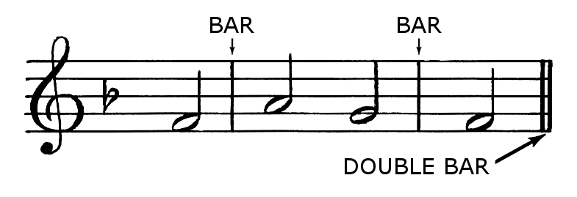

The BARs are also called measures.

So the time signature lets you know how much a beat is work in music notes. The song will increase in speed depending on the tempo (BPM)  
<https://www.reddit.com/r/explainlikeimfive/comments/24et1c/eli5_rhythm_tempo_how_to_find_the_main_beat_and/>

^This guy explains it really well, it will be in the first comment, its long but pretty much what it is.